# 5. Risk Management

Risk Management is the process of identifying the strength, weaknesses, opportunities, and threats of our project. It is important in the project because without it, we cannot define our objectives for the future. And if we define our objectives without taking risk management then we may lose the track once any risk occurs. Our project will go effectively if the risk is managed wisely.

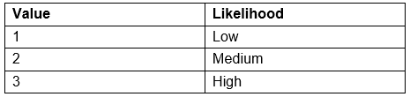

Fig: Risk Likelihood

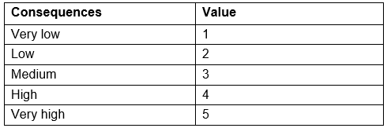

Fig: Risk Consequences Values

For identifying risk, we will use the following formula:

**Impact = Likelihood x Consequence**

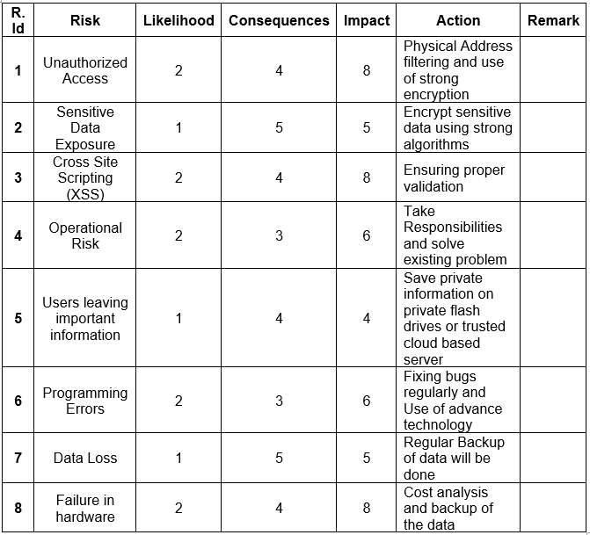

Fig: Risk Management Table

Some of the basic steps of risk management lifecycle are explained below:

1. **Identification:** We cannot manage our risk if we don’t know the risk. So identifying risk is the first step for risk management.
2. **Assessment:** Once the risk is identified, it needs to be examined in terms of likelihood and impact. This will then identify which risks should be in first priority.
3. **Treatment:** After accessing the risk, an approach for treating each risk should now be characterized.
4. **Monitoring:** Once the risk is identified, accessed and treated now we cannot leave it. It needs to be processed and reviewed, which is essential for proactive risk management.
5. **Reporting:** After all these four stages, the report of each four stages above should be described briefly for effective risk management.